
禮拜程序 The Order of the Service
聚集上帝面前 Assembling in the Presence of God
前 奏Prelude
宣 召Call to Worship
*讚美吟詩Praise & Adoration 26今阮感謝上帝 Now thank we all our God
兒童信息 Children’s message
感謝祈禱Prayer of Thanksgiving
信仰告白Affirmation of Faith 使徒信經The Apostles’ Creed
認罪祈禱Prayer of Confession 332 耶穌，著記得我 Jesus, remember me
赦罪恩言Assurance of Pardon
啓應讀經Response in Scriptures 詩篇Psalm 106:1-6; 19-23
獻 詩Anthem 主愛有多少 How great is the Lord’s love?
恭受上帝話語 Listening to the Word of God
讀 經Scripture 腓立比書Philippians 4:1-9
證 道Sermon 凡是⋯⋯Whatever⋯⋯
回應上帝福音 Responding to the Gospel of God
*回 應 詩Response Hymn 603上帝作咱安全要塞
A Mighty fortress is our God
*奉 獻Offering 375(4) 著帶啥禮物What gift can we bring
歡迎報告Welcome & Announcements
代 禱Prayers of the people 主禱文The Lord’s Prayer
*頌 榮Praise 618咱著信靠上帝Put thou thy trust in God
*差遣祝禱Sending & Benediction
*阿 們 頌Threefold Amen
殿 樂Postlude
（*會眾請起立；若不便起立，請以心一同參與。 *Please stand in body or in spirit）

2026
10/11
聖神降臨節後第二十主日 Vol. 43
Twentieth Sunday after Pentecost No. 41



會內消息 Church News
- 週三查經班：以賽亞書第二章。Wednesday Bible Study: Book of Isaiah 2.
- 小會接納長執提名委員會之提議，因於遷堂之須，所有長執延長一年任期，不改選，10/25 將舉行選舉和會。
The Session approved the recommendation of ONC to extend the terms of office of The current elders and deacons for one additional year next year, due to the needs of the church relocation project. Congregational meeting will be held on October 25.
- 10/31 在州立公園秋季旅遊, Fort Yargo State Park（210 S Broad St, Winder, GA 30680）賞楓、健行、用餐、聊天，共度美好時光！活動詳細請向季芳執事洽詢並報名
Join us for a fall outing at Fort Yargo State Park (210 S Broad St, Winder, GA 30680) on October 31! Enjoy the beautiful fall foliage, hiking, a meal, and fellowship as we spend a wonderful time together. For more information and to register, please contact Deacon Jifang.
- 感謝上帝的帶領與恩典！ 帶領我們進入新堂準備階段。願主紀念同工的辛勞, 請為新堂的事工事奉代禱, 並為新堂籌備經費奉獻。
We give thanks to God for His faithful guidance and abundant grace as He leads us into the preparation stage for our new church home. May the Lord remember and bless the hard work and dedication of all our coworkers. Please continue to pray for the ministries and service of our new church, and prayerfully consider giving toward the expenses and preparation of our new church.
- 建築硬體：昆峰長老。建築維護、修繕與硬體設施相關工作。
Physical Plant (David). Building & Facilities maintenance, repairs, and facility-related needs.
- 環境清潔：其慧、悅珉長老。園藝、清潔、資訊及辦公用品等。
Housekeeping (Susannah & Amy). Landscaping, cleaning, IT, and office supplies.
- 空間管理：淑婉長老。空間分配、安排、清潔與維護。
Space Management (Showan). Room assignments, space cleanliness and maintenance, and coordinating future use of the church facilities.
- 法律文件（慧貞長老）。合約與法律相關行政文件處理。
Legal & Documentation ( Huey )
Assist with contracts, legal documents, administrative paperwork, and related documentation.
教會地址｜Address：10590 Parsons Rd, Johns Creek, GA 30097
- 懇請在有感動或紀念慶祝意義的日子，兄姐請向黃遠亮執事聯絡獻餐，或在公告欄上登記。
We invite you to sign up to provide a Sunday lunch. Please let Deacon Yuan-Liang know.

上週奉獻 Offerings for last week
支票抬頭請寫ATPC，並請務必加上中文姓名或「有志」
經常 | 有志 | 建堂基金 | 感恩 | Zelle | 主日總計 | 九月網路扣手續
$ 1030 | $ 100 | $ | $ | $ | $ 1030 | $
肢體代禱 Prayer Request
李英毅、李南雄、王輝美、陳嘉明、鄭芝蘭、康麗容、林幸子、賴志鋒、吳建勳、David Seidenberger、Teresa Taft.

Oct 11 Oct 18

周懋秀Matthew

陳慧貞Huey

曾瑋誠Patrick
陳淑婉Showan

張振昌Jason
張達偉David
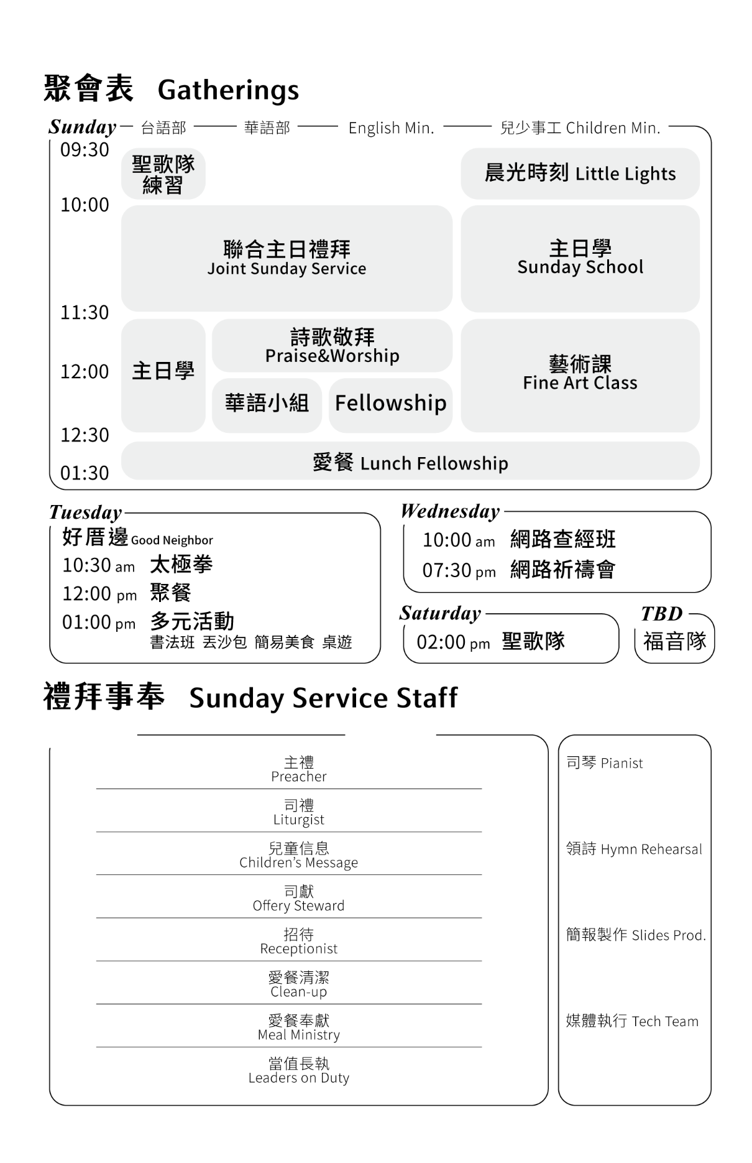  羅敏珍 Grace |  | 李心聿 Rachel
柯賢利 |  | Michael
Phillip |  | 羅敏珍 Grace
張振昌 |郭雲吉 |  | 劉季芳 | 郭雲吉
江月美| 李榮魁 |  | 江月美 |李榮魁
兒童部 CM |  | 男士 Men
ATPC |  | ATPC
陳慧貞 | Phillip |  | 陳慧貞 | Phillip

